Sprint Retrospective – 01.05

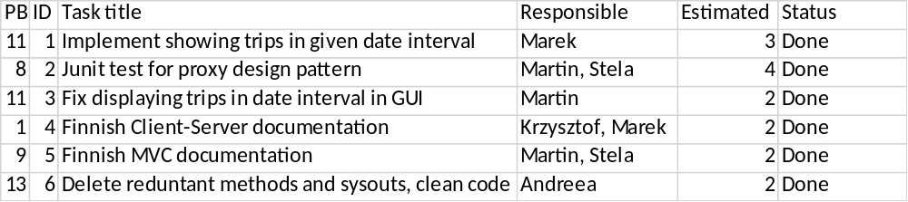

This sprint finished the Construction phase of UP.

During this sprint we have finished all the coding tasks. We have created Junit test to test proxy design pattern. We have also finished client-server and MVC documentations. After all this was finished we ran inspection on the code using which we have found and deleted all reduntant methods and sysouts from the code.

